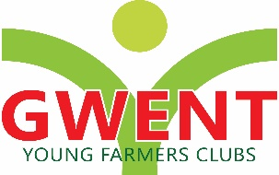

RALLY SIGN COMPETITION

ELIGIBILITY: Clubs may enter one sign for the County Final.

HEALTH AND SAFETY – All Competitions carried out at County level must comply with Health and Safety legislation and meet the relevant safety standards.

PROCEDURE – ‘THEME – EMERGENCY SERVICES’

a) The sign to be a minimum size of 8’x4’, and suitable for erecting in a prominent site. It should be easy to read from a distance.
b) The sign should promote and advertise the Gwent YFC County Rally 2024 in the Clubs local area.
c) The sign should be waterproof to allow erection two month’s prior to the County Rally.
d) The sign must include the information regarding the event / venue / date of Rally

Competitors must bring the finished design for display at autumn competitions weekend

SCALE OF MARKS

Marks will be awarded as follows:
Artistic achievement 30
Suitability 30
Overall effect 40
TOTAL 100

GENERAL Gwent Federation will not be responsible for any expenses incurred by competitors.

The Judge's decision is final

