GWENT FEDERATION OF YOUNG FARMERS’ CLUBS
President: Mr Glyn Davies Chairman: Mrs Amy Phillips Organiser: Mrs Jemma Rodgers

YFC Office,
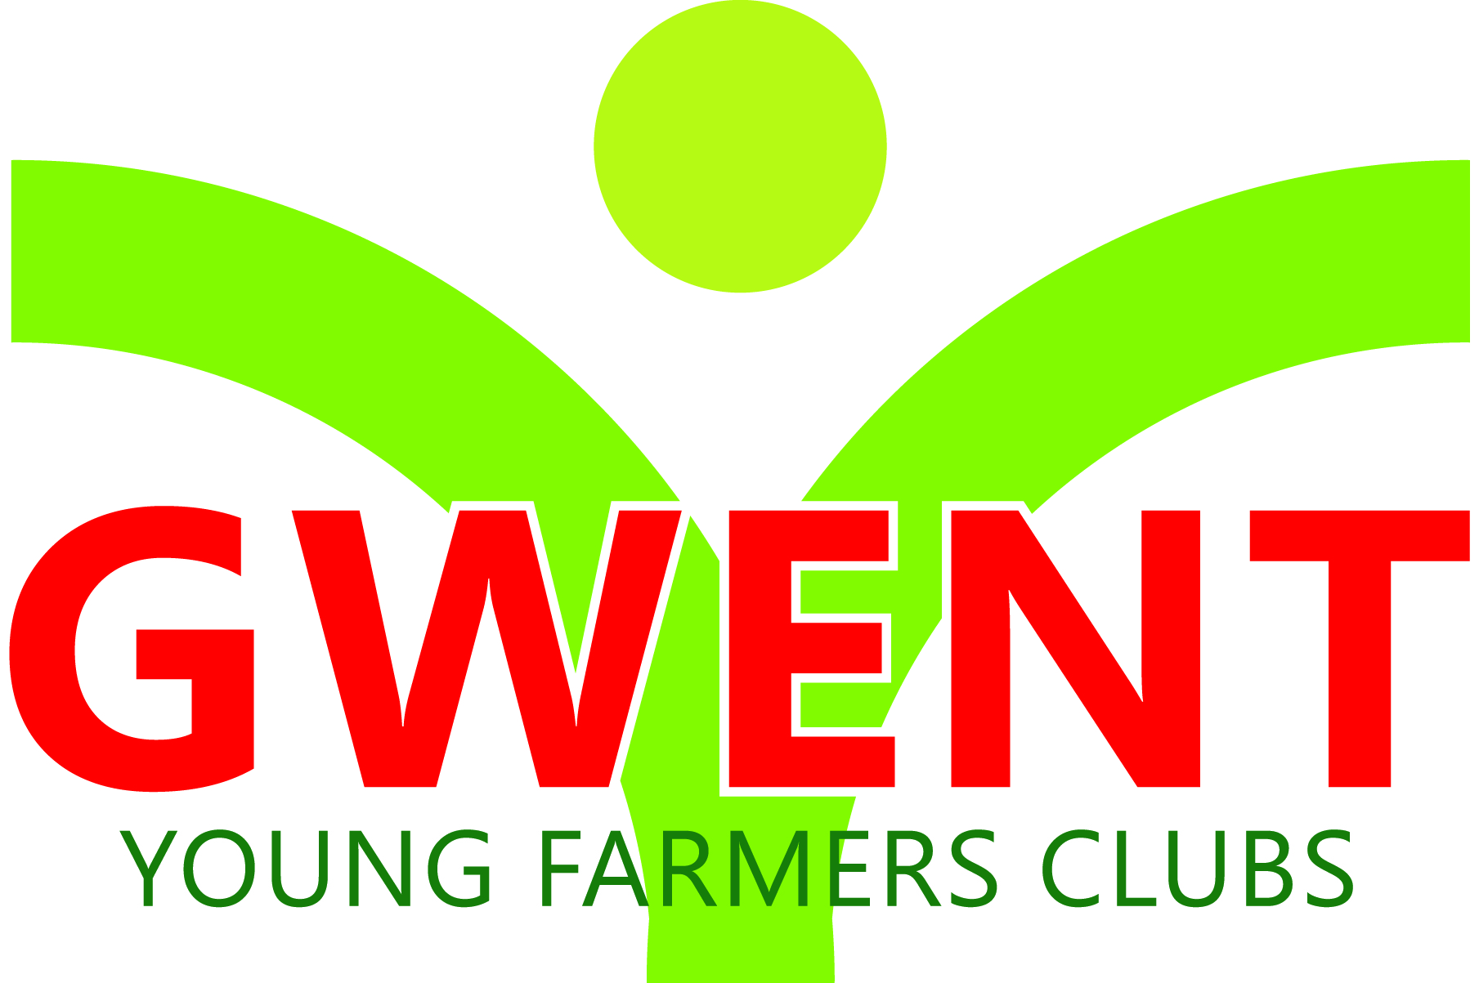
Coleg Gwent,
Usk Campus,
Usk,
Monmouthshire,
NP15 1XJ.
Tel :01291 672602
gwent@yfc-wales.org.uk
www.gwentyfc.co.uk

Dear Committee member,

The next meeting of the Competitions Committee will take place on Monday 8th January 2024 in the YFC Meeting Room at Usk Campus at 8.00pm

Yours faithfully

Laura Morgan
Competition Chairman
AGENDA

- Apologies

- Minutes: to receive minutes of the last meeting held on 4th December 2024 (111/CO/2023 – 120/CO/2023)

- Matters Arising

- Correspondence

- Review Skittles

- Drama

- Pig & Dairy Competition March

- Clay Pigeon Shoot

- Sports Day

- AOB

