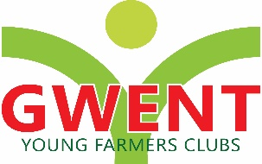
GWENT FEDERATION OF YOUNG FARMER’S CLUBS
Minutes of the Executive Committee Meeting held on Monday 23rd January 2023 at 8pm at Gwent County Office

Chairman:  Secretary:  Abergavenny:  Bedwas:  Crucorney:  Raglan:  Usk:  Wentwood:  Co-opted:  Apologies | Laura Bowyer  Jemma Rodgers  Jack Bodily, Cerys Williams, Eleri Williams, Ella Morgan  Caroline Perkins, Heidi Perkins, Catherine Bartlett  Eleanor Price,  Sophie Roderick, Thomas berry  Dominic Hampson- Smith, Cat Webster  Huw Morgan, Ali Morgan  Kitty Bodily, Mark Taylor, Glyn Davies, Amy Phillips, Laura Bowyer, Dan Jones  Nerys Lewis, Rhiannon Williams, Will Morgan, Millie Arnup, Pheobe Meadmore, Sam Pritchard, Nerys Lewis, Rhiannon Williams.
01/EX/23 | Apologies  Were given -above.
02/EX/23  03/EX/23  04/EX/23  05/EX/23  06/EX/23  07/EX/23 | Minutes: Minutes were signed as true and correct copy (55/EX/22-63/EX/22)  Signed by Laura Bowyer as a true and correct record.  Matters Arising  Jemma to change the attendance as it’s incorrect.  Correspondence  Received a card from Church thank us for the donations at the church. They are buying new advent candles with the money received.  Committee meetings Gwent, Wales and NFYFC  NFYFC Committee  Not had a council meeting so there is nothing to report.  Will address item 6  Raiff Devlin – approached Gwent to 2nd is attempt to be vice chairman.  Letter below from Raiff  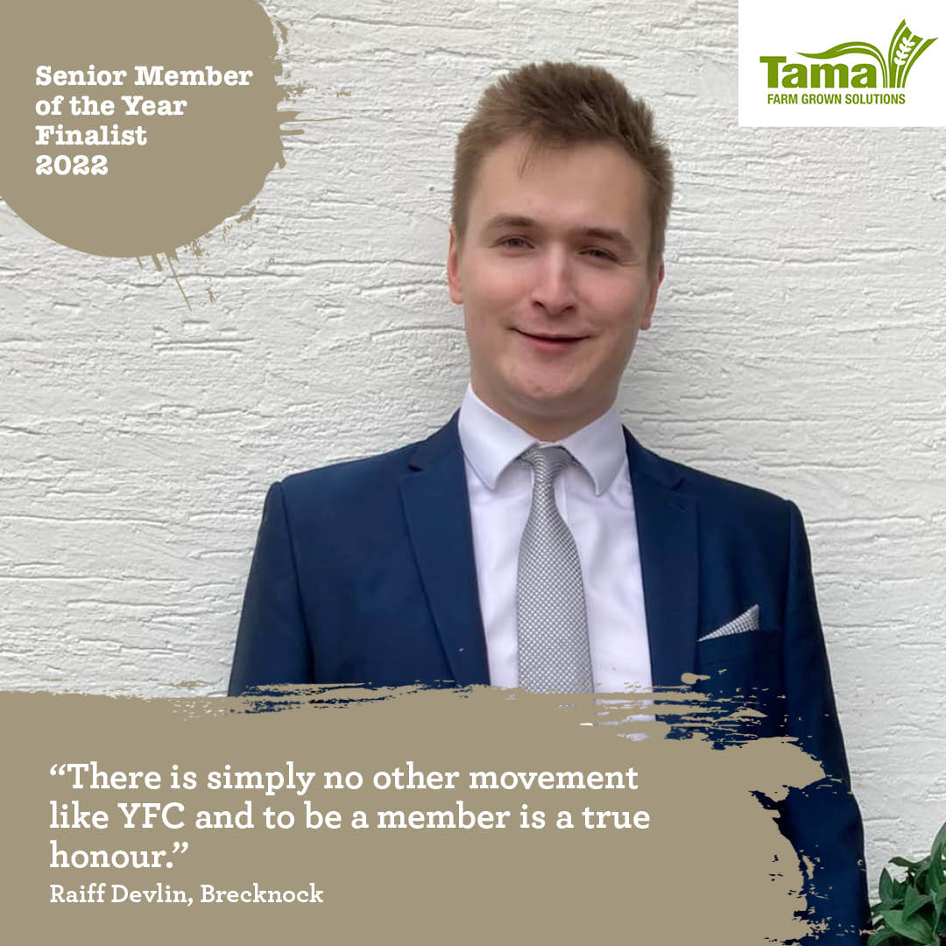  To all at Gwent YFC,  My name is Raiff Devlin, and I am standing to become your next NFYFC Vice Chairman for 2023-24.  YFC means so much to me. Since the age of 10, it has provided me with a place to learn new skills, have fun, and, most importantly, make lifelong friends. Growing up in a rural community can be challenging and isolating, but with YFC I never felt like I was alone. Every year there was always something to look forward to: from the dramas, with all the props to build and lines to learn, to the rally, with the tug-of-war and the dance afterwards! My favourite event, however, has always been public speaking. My proudest YFC moment must be winning the Best Panellist Award for Brainstrust back in 2019.  As I got older, I wanted to become more involved with YFC and learn how it was run. I was elected as Chair of my local club, Pontfaen YFC, on multiple occasions, and in 2022, I became Vice County Chairman for Brecknock. I love working with other members and supporters to create a YFC experience that is even better than before.  I want to be your next NFYFC Vice Chairman because I believe I have the skills, experience, and passion necessary to ensure that our movement delivers for you all. As a proud Welshman, I recognise the importance of representation at trustee level for members from all our nations, to ensure that everyone is represented equally. As NFYFC is made up of nations with multiple languages, I also believe that each one, including the Welsh language, should have a place in NFYFC meetings and events.  As I am sure you are all aware, there are several challenges facing NFYFC. These include the effective promotion of agriculture, financial stability, membership cost and the safeguarding of our members. Getting these things right is challenging and requires effective leadership that I am confident I can provide.  If elected as your next NFYFC Vice Chairman for 2023-24, I will:  - Build upon the successes of NFYFC by creating a movement that responds to challenges by transforming them into opportunities.  - Represent all members from every corner of England, Wales, Isle of Man, Guernsey and Jersey with fairness and equality.  - Provide support to our soon to be Chair Rosie Bennett and the NFYFC officer and staff team.  - Uphold and protect the democratic values of the YFC movement.  - Continue to unite our membership.  - Build a NFYFC fit for the next 90 years and beyond!  I am forever grateful for my time in YFC so far. Now, having spent over 15 years in the movement, my goal is simple; I want to continue to provide young people from rural areas with a place that allows them to learn new skills, make new friends, and have fun.  If you share my goal, lend me your vote at the council meeting on February 26th and let’s make it all happen together.  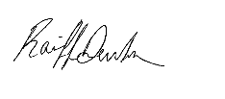  Yours sincerely, and with best wishes for the upcoming year,  Raiff Devlin  Are we in favour of 2nd ing this? Agreed  WALES YFC MEETINGS  Wales Council  YPV has been permanently cancelled, it was decided in the meeting after all other options were looked at.  Ali Morgan and Rhiannon Williams were part of the YPV working group.  Ali Morgan to give a review – Was unsure how it was cancelled the last discussion was to look at options and no decision made  Dan Jones – RWS will be giving the 5K  Jemma Rodgers – RWS investigated all the options available to try help us keep the YPV to a degree. There was no option found and the council decided there was no option but to cancel YPV. RWS have agreed to continue with the 5k.  Ali Morgan – We went around in circles at the meeting they were destined to fail when they decided to scale it right back. I feel sorry for the younger members who won’t get to experience what we have over the years. They blame town and Pen Maine although that’s not the problem.  Dan Jones – it was noted that no young farmers will be allowed to camp at the site. Only over 30’s / families only.  Dominic HS – Disappointed that the YPV has gone but I knew it was coming. Disappointed with the lack of support and help from the show. The 5K isn’t much compared to the money they have give them. At the rural affairs meeting Mared want them to work with kids and rural affairs.  Rural Affairs – Dominic HS  Rural affairs conference went well lots of support from Gwent.  Nigel Owens was the guest speaker and hearing his story was great.  Also lots of other good stories of how people built up their business.  British wool scheme getting booked up  Over 16’s only on the form but may accommodate 15 if already shearing – deadline 31st March  Lamb scheme – put on more evenings and day sessions to try get more people in the Gwent area, not many do it with us.  Rural affairs promote at field day.  Study day is in Northern Ireland 23  Lots of business approaching YFC’S to work alongside them.  International – Nerys Lewis – (Jemma read out a email from Nerys as she could not be present)  We had a record breaking year in terms of applications, with over 60 people receiving places on trips this year. The interviews were mainly done in person, and anyone with exceptional circumstances was offered a zoom option, this will be reconsidered for next year as it made the day another harder and took one member of staff to work with it all day.  UPDATE ON THE 2023 PROGRAMME  Agri Eye, Orkney and Isle of Man have all now been handed over to Lee, as Rural Affairs Officer. He is well underway with preparations for these.  RYE trips – just waiting on RYE for us to submit the team info, etc.  Interrailing and Mystery – we will hopefully get a date sorted for both. Interrailing will hopefully meet in person to discuss their plans.  USA Road Trip – all going ahead with dates set.  Elwyn Jones Scholarship – Last year’s winner is looking to book flights, so hopefully both members will be putting plans in place soon.  Junior trip – this has proved to be very expensive. So, we are now looking to hist 1 overnight stay with a farm tour on the Saturday, activities in the evening and then a morning of activities on the Sunday.  A proposal has come from Scotland to hold a 5 nations conference that will travel round the 5 with Wales looking to host in 2026 or 2027. Talks are still ongoing about the structure etc.  Finally, we'll done to all members of Gwent for applying its great to see so many Making this opportunity.  Rhiannon Williams -Marketing and Events (Dominic Hampson Smith read out a message from Rhiannon has she couldn’t be present)  Events & Marketing  Letter from competitions committee asking us to help with social media coverage at competitions and posting results on social media real time.  The committee will have a rota to achieve this. Ynys Mon have an official county photographer so they will help at this year’s Eisteddfod.  Letter from Aled Jones CEO of the Royal Welsh Agricultural Society regarding YPV The RWAS do not want to see the YPV go but are supportive of any decision we make and appreciate the work that has been put into salvaging it.  They want to ensure the safety of member during the show and will work with us on this. They have agreed to continue their £5000 yearly donation that is usually to the YPV regardless. They have offered the use of the Showground heavily discounted for a standalone event perhaps a music festival.  The Committee feel the YFC calendar is already fully booked, would people travel to Builth for this?? Still the issue of camping/logistics cost etc so have decided to leave it this year but leave the offer open perhaps for 2024.  Think it is best to focus on the AGM in September. Looking to run something from the YFC centre at Spring Festival - perhaps a scavenger hunt or photo opportunities. Will liaise with rural affairs and youth forum. A promo video was made by Cywain last year of YFC @ RWS - this will be released in the summer aiming to get members back into YFC for the new YFC year.  Considering making one for the Eisteddfod - maybe members could be utilised to make this as not cheap. Welsh Music Day Lip Sync Competition- lip sync up to 60 secs of a Welsh song. Each county must provide at least one entry.  Possibility of prize money - Wales hoping for £5000 grant to produce a song so will be dependent on this. I have shared the post around - please pass to clubs. Deadline 30th Jan Farm Safety Week - (week of spring festival)  Need to promote this - they have different quarterly themes we are hoping to work with these and get counties to make promotional videos. Mental Health To link with the ‘Mind your head’ campaign Discussed DPJ training All county and Wales staff are having training on this Wales YFC AGM 15/16 September In Cardiff Need to promote We are looking at different attractions/activities Possible golf theme? Hoping to start promo by May ahead of some YFC summer breaks new vice chair of the committee elected - Caryl Jones Carmarthenshire Room for 6 experts on the committee - recommendations from other counties - do we have anyone who would benefit the committee? International Women’s Day Wales have the official toolkit Promote through members videos etc maybe a podcast Looking to get back into podcasts.  Wales Competitions – Dan Jones  Entertainments – Saturday day and night £15 each  £25 all day and £20 on the Sunday  £40 for both days  Gwent will be on at 2PM Rehearsal and 4pm performance.  Results are at 9:30pm  Eisteddfod challenge to get the judges they are looking for payment. Currently pay £120 but they want more. They have offered £150 plus hotel and travel. They are difficult people to deal with.  Eisteddfod is the 30th October and the venue is confirmed.  Winter fair review  There were issues with the beef.  Maybe reduce the ring but they are sticking with the 2 rings. If it’s a little more organised it will be ok with 2 lines of 4  Lamb trimming – struggled with entries in all the other counties.  Dan suggested the split age categories but due to other counties struggling with the numbers it was rejected.  Radnor – suggested not using hand shearers and going electric.  Dan disagreed.  It was confirmed to stick to the hand shearers.  Stock judging – some members were disqualified for not using Dunbia cards  Dunbia cards and coats are to be worn and used.  Rules and Themes for next year  Emergency services and RNLI 200th year  Theme for floral keep it emergency services.  RWS – Ideas finalised at the next meeting.  Brecknock suggested with the farm safety first aid – for everyone to be given a scenario and judged on the same thing at the RWS  Bryan Rees – will help with the farm safety he is good at the H&S side of things. Jemma to contact him -need to find is number.  Cookery – struggle to get up and running now. They are looking to run more of a ready steady cook competition, so it’s more judged on the day.  Maybe consider for our other competitions  NFYFC Council – Laura Bowyer  Ed Dungait great time at county ball and still want to go ahead with the Ball next year even though it made a loss last year.  We pay 50% Levy to Wales and Ed Dungait wanted to look at this.  Board of management want to increase the Levy next year.  John James from Radnor to be adopted onto the board of management in February.  Ed will stand down in February.  Devon YFC are proposing to raise the age of YFC to 12 from 10  If you want to put a motion forward for anything it needs to be done ASAP  Gwent YFC competitions Committee – Dan Jones  Reminder to the clubs for the ICC tech on the 16th Feb  Ticket sales please push.  Cast members will also require tickets.  Tom Berry talked about the cups.  Wales YFC Staff Association meeting  Baby beef – any ideas how to increase entries or improve the competition.  Kitty Bodily – the big boys are entering their calves to get through.  Jack suggested splitting the weight category.  Jack/Kitty to send Jemma some suggestions to send through to Wales.  Welsh water scholarship and animal health night with Glamorgan at some point at the market  Tug of war that NFYFC offered is not for Wales members – Wales looking at options.  Social committee – Sophia Vassallo  Laura Bowyer - it was a huge disappointment that there were so few at the 12 clubs of Xmas. I know a few were late coming but it was agreed to do it, If you don’t want to then don’t agree to it.  Eleri Williams stated that it’s a problem with the weekend is work commitments etc  Eleanor Price – it’s been very Chepstow heavy lately with lots happening over there.  Next pub of the month is in Abergavenny 11th February.  Sophia and Jack to sort the venue.  Dance after field day – Maybe Llanarth hall  Junior social will be after the entertainments.  County council small holdings  Discussion about the fact no members got the lease at Alun’s place.  It was disappointing to hear that the person who did is already established and has a sizeable business.  Laura is wondering if we need to do anything about this for the future  Laura has spoken to Stella Owens NFU and she said not to send a letter  Suggested to invite someone to come and speak and find out what the criteria is.  The person who got Aluns put In a bid 3 x higher that some others.  Glyn Davies thinks we should have a meeting to discuss.  Laura Bowyer – Reservations is about generation to generation.  Ali Morgan - has an issue with MCC housing in general, where are people going to live. There needs to be more affordable housing  Dominic Hampson-Smith – agree on the housing we do need to do something and maybe need to put a agenda together.  Mark Taylor – Dealt a lot with MCC. Bought an ex-county council holding and they don’t have a clue what they are doing. Has grazing agreement on land but hasn’t had contact over the years. A few years they didn’t charge for the land then suddenly had a bill 4 years later, even though he got in touch.  Succession policy doesn’t happen anymore.  Tried in Pembrokeshire twice once got further than the other. they are keen on getting youngsters in they start small and go big after time.  Maybe that’s something to put to them.  Laura Bowyer – Should I contact Stella and ask advice.  Dom HS – Suggested they had a meeting with her too.  Suggested to contact local councillors and talk to them about the situation.  Ali Morgan – Jane Mckenna from the Wentwood area  Catherine Bartlett – suggested getting a freedom of request for the policies of tenancies.  they must give it to you with in so many days.  Was agreed to create the rural affairs working group and decide a way forward- Dom and Ali will be two members involved.  AOB  Tom Berry – Junior speaking judge Jackie Woollatt not received a thank you letter  Crucorney event – 7th May cross ash hall.  Meeting closed 9:40pm  Next Meeting 27th March 2023  SIGNED TRUE AND CORRECT RECORD - ____________________________________________________________________

