GWENT FEDERATION OF YOUNG FARMERS’ CLUBS
President : Mr Glyn Davies Chairman : Miss Laura Bowyer Organiser: Mrs Jemma Rodgers

YFC Office,
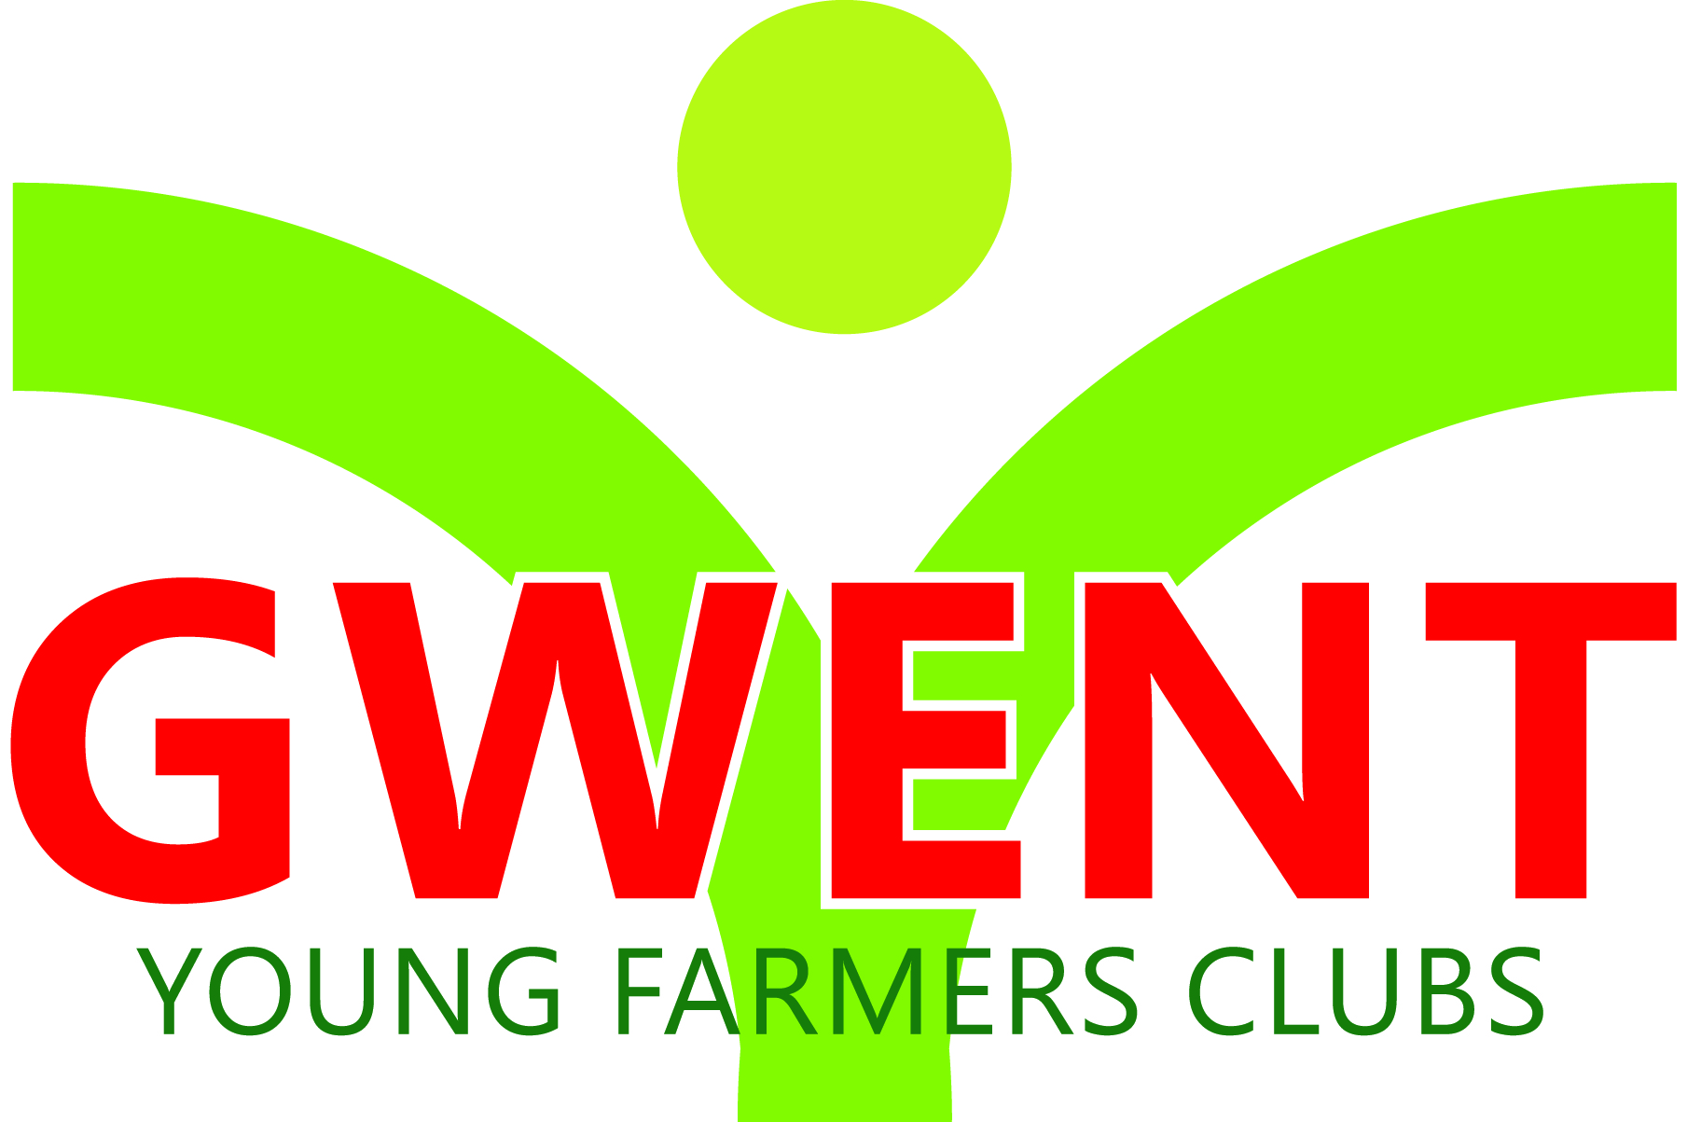
Coleg Gwent,
Usk Campus,
Usk,
Monmouthshire,
NP15 1XJ.
Tel :01291 672602
gwent@yfc-wales.org.uk
www.gwentyfc.co.uk
Monday, 16 January 2023

Dear Committee member,

The next meeting of the Executive Committee will take place on Monday 23rd January 2023 in the YFC Meeting Room at Usk Campus at 8.00pm.

Yours faithfully

Laura Bowyer
Gwent YFC Chairman
AGENDA

- Apologies

- Minutes: to receive minutes of the last meeting held on 21st November 2022 (55/EXEC/22 – 63/EXEC/22)

- Matters Arising

- Update from committees

- NFYFC Council
- Wales council
- Wales sub committees
- Rural affairs - Dom
- Marketing & events - Nannon
- International - Nerys
- Gwent Competition and rally
- Wales Staff association meeting - Jemma
- Gwent Social committee – Sophie

- County council small holdings

- Raiff Devlin

- AOB

