GWENT FEDERATION OF YOUNG FARMERS’ CLUBS
President: Mr Glyn Davies Chairman: Miss Laura Bowyer Organiser: Mrs Jemma Rodgers

YFC Office,
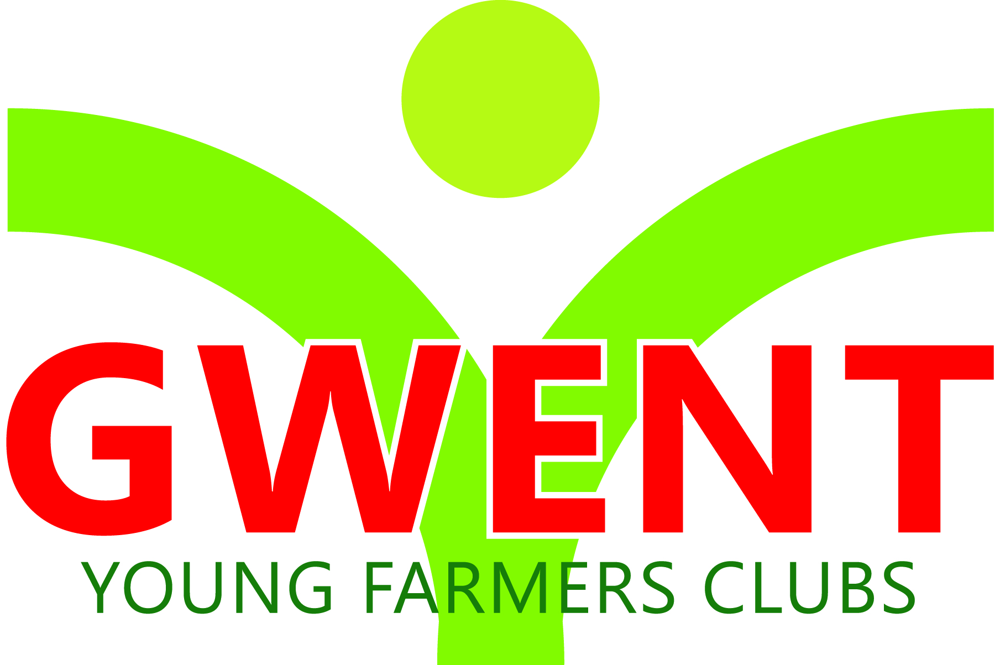
Coleg Gwent,
Usk Campus,
Usk,
Monmouthshire,
NP15 1XJ.
Tel :01291 672602
gwent@yfc-wales.org.uk
www.gwentyfc.co.uk

Dear Committee member,

The next meeting of the Competitions Committee will take place on Monday 5th December 2022 in the YFC Meeting Room at Usk Campus at 8.00pm

Yours faithfully

Dan Jones
Competition Chairman
AGENDA

- Apologies

- Minutes: to receive minutes of the last meeting held on 7th November 2022 (109/EXEC/21 – 118/EXEC/21)

- Matters Arising

- Review Carcass competition

- Review Winter fair English and Welsh

- Review Public Speaking

- ICC

- Field Day Judges

- AOB

