GWENT FEDERATION OF YOUNG FARMERS’ CLUBS
President : Mr Alun Morgan Chairman : Miss Abbie Williams Organiser: Mrs Jemma Rodgers

YFC Office,
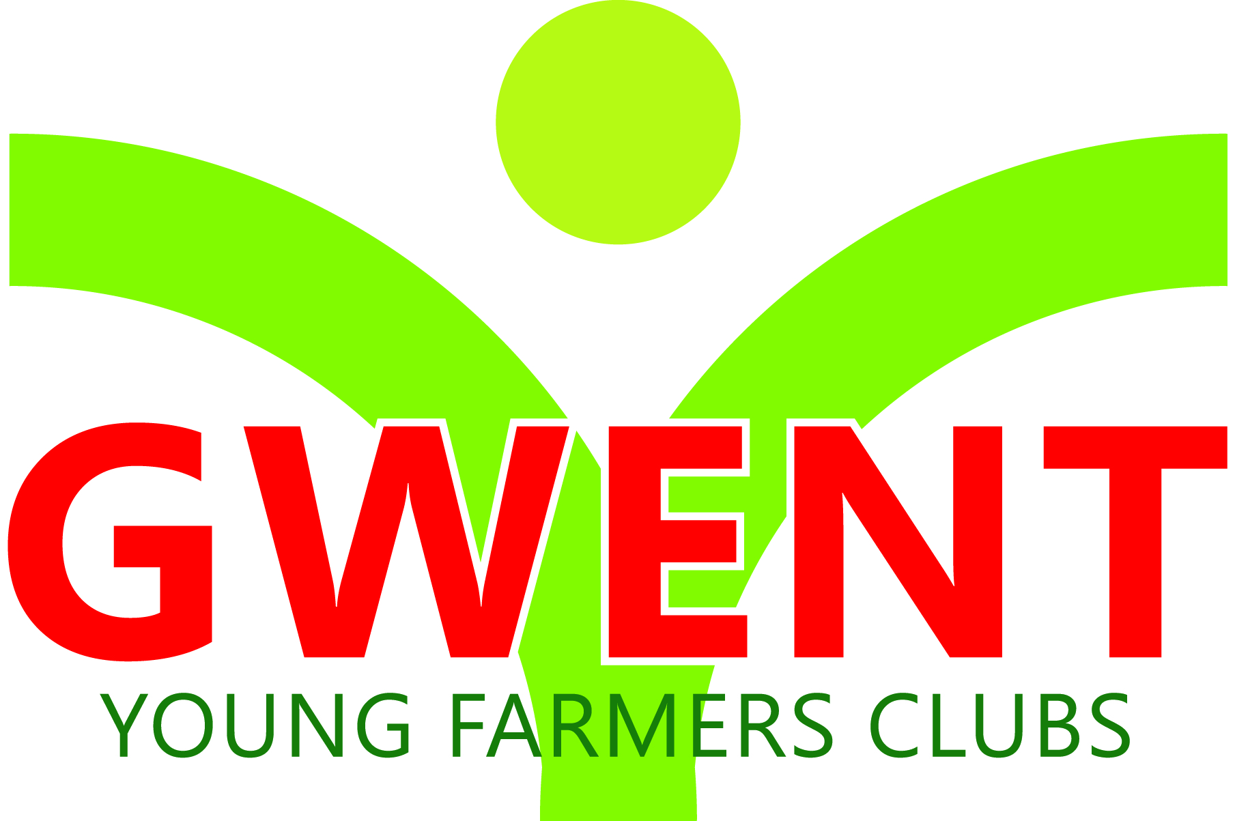
Coleg Gwent,
Usk Campus,
Usk,
Monmouthshire,
NP15 1XJ.
Tel :01291 672602
gwent@yfc-wales.org.uk
www.gwentyfc.co.uk
Friday, 20 November 2020

Dear Member,

The next meeting of the Competitions & Executive Committee will take place on Monday 23rd November at 8.00pm on zoom.

Please make sure that all your Club Representatives are aware of the meeting, and that you have discussed the points on the Agenda, and that your Club views are put forward. Further copies of the agenda will be available on the night.

Yours faithfully

Abbie Williams
County Chairman
AGENDA

- Apologies
- Minutes: to receive minutes of the last meeting held on November 2nd
- Matters Arising
- Correspondence
- Review Winter Fair competitions
- Review nfyfc stockjudging
- Review Wales Yfc stockjudging & winter fair
- Information
- Club social
- Alun
- International update
- Nativity play clips
- Xmas elf on the shelf photos
- Safeguarding Policy
- County officer training
- County socials
- AOB

Next meeting 14th December
After this we will hold it in 4 weeks if that’s ok with everyone which will be the 11th January 2021

