GWENT FEDERATION OF YOUNG FARMERS’ CLUBS
President: Mr Glyn Davies Chairman: Miss Laura Bowyer County Organiser: Mrs Jemma Rodgers

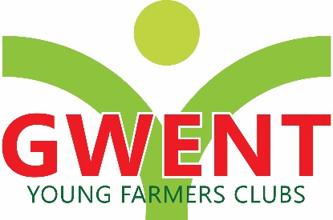
YFC Office, Coleg Gwent,
Usk Campus, Usk,

Monmouthshire,
NP15 1XJ
Tel :01291 672602
gwent@yfc-wales.org.uk
www.gwentyfc.co.uk
05 September 2023

Annual County Executive AGM of the Gwent fed of YFCs

The 87th Annual General Meeting of the Gwent Federation of Young Farmers’ Clubs will be held at 7:30 pm on the 7th September 2022 at Llanarth Hall, NP15 2AU

Mr Glyn Davies

County President

AGENDA

- Welcome from the County President
- Receive apologises for absence
- To confirm the minutes of the 86th AGM of the Gwent Federation of Young Farmers’ Clubs
- Matters arising from the minutes
- Nomination of Tellers
- Adoption of the county constitution
- Presentation of the annual report
- Presentation of the statement of accounts and report by county treasurer
- Presentation of the county membership return
- Election of county President
- Election of County President elect
- Election of county life members, vice-Presidents & Gwent YFC leaders
- Election of County Chairman
- Election of County Vice Chairman
- Election of County officers
- Election of committees
- Election of the independent accountants
- Presentation of awards

