GWENT FEDERATION OF YOUNG FARMERS’ CLUBS
President : Mr Alun Morgan Chairman : Miss Abbie Williams Organiser: Mrs Jemma Rodgers

YFC Office,
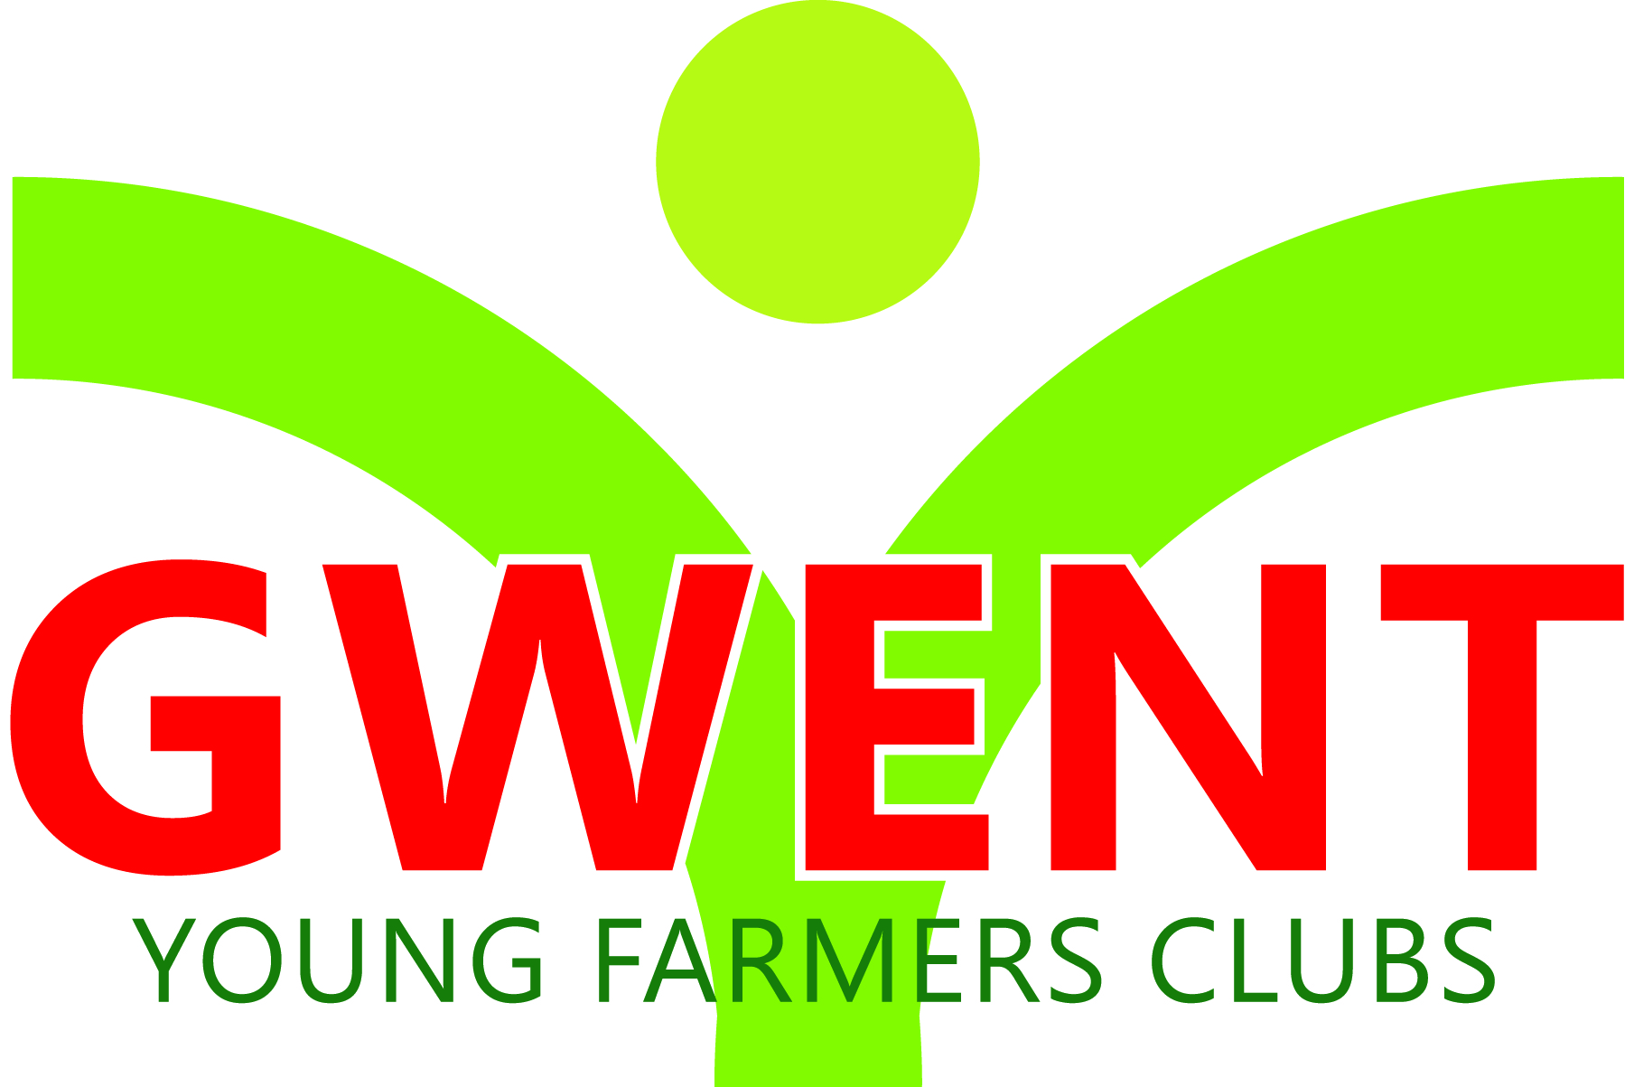
Coleg Gwent,
Usk Campus,
Usk,
Monmouthshire,
NP15 1XJ.
Tel :01291 672602
gwent@yfc-wales.org.uk
www.gwentyfc.co.uk
Monday, 11 January 2021

Dear Member,

The next meeting of the Competitions & Executive Committee will take place on Monday 11th January at 8.00pm on zoom.

Please make sure that all your Club Representatives are aware of the meeting, and that you have discussed the points on the Agenda, and that your Club views are put forward. Further copies of the agenda will be available on the night.

Yours faithfully

Abbie Williams
County Chairman
AGENDA

- Apologies
- Minutes: to receive minutes of the last meeting held on Monday 14th December (38/co/20 – 45/co/20)
- Matters Arising
- Correspondence
- Competitions, Training and Socials
- Charity Race (eg Duck)
- Social Media take over
- FUW Big breakfast
- Ideas for Projects for Grants
- LEVY
- AOB

Next meeting 1st February 2021

