GWENT FEDERATION OF YOUNG FARMERS’ CLUBS
President : Mr Alun Morgan Chairman : Miss Alyssia Thomas Organiser: Mrs Jemma Rodgers

YFC Office,
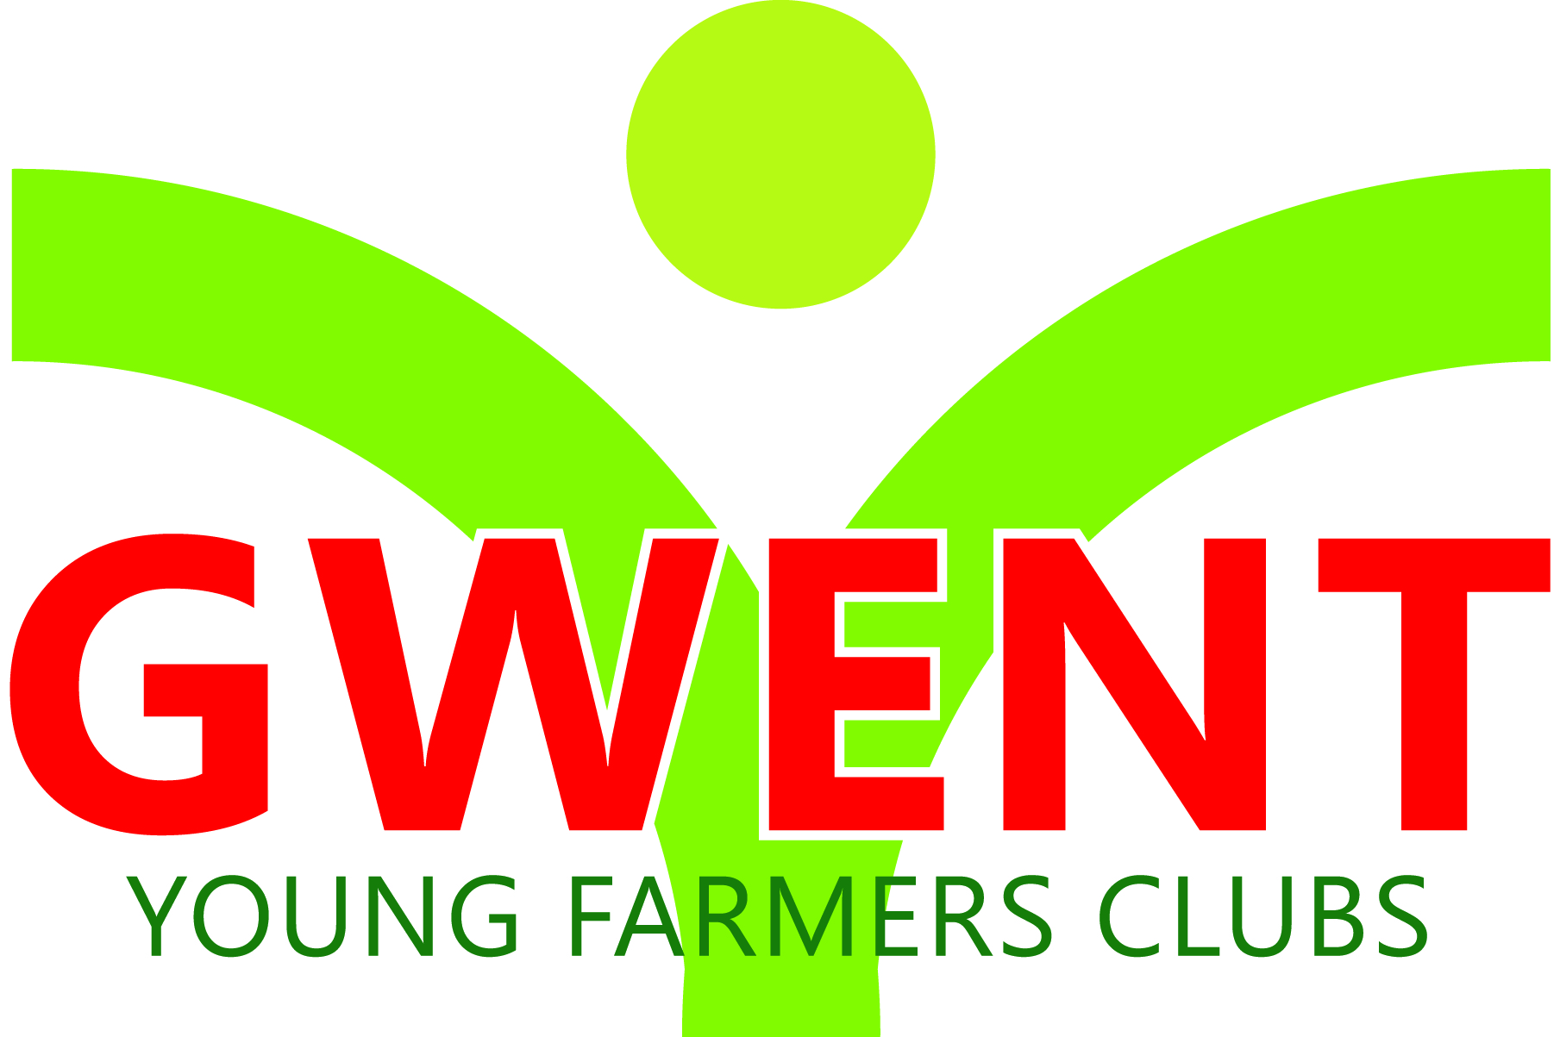
Coleg Gwent,
Usk Campus,
Usk,
Monmouthshire,
NP15 1XJ.
Tel :01291 672602
gwent@yfc-wales.org.uk
www.gwentyfc.co.uk

Monday, 24 February 2020
Dear Member,

The next meeting of the Rally Sub-Committee will take place on Monday 2nd March 2020 in the YFC Meeting Room at Usk Campus immediately following the meeting of the Competitions Committee, at 8.00pm.

Please make sure that all your Club Representatives are aware of the meeting, and that you have discussed the points on the Agenda, and that your Club views are put forward. Further copies of the agenda will be available on the night.

Yours faithfully

Amy Tamplin
Rally Chairman
AGENDA

- Apologies

- Minutes : to receive minutes of the last meeting held on 3rd February 2020

- Matters Arising

- Correspondence

- To Review arrangements to date

- Steward Suggestions

- Judge Suggestions

- Any other Business

- Date of Next Meeting Monday 6th April 2020

