GWENT FEDERATION OF YOUNG FARMERS’ CLUBS
President: Mr Glyn Davies Chairman: Mrs Amy Phillips Organiser: Mrs Jemma Rodgers

YFC Office,
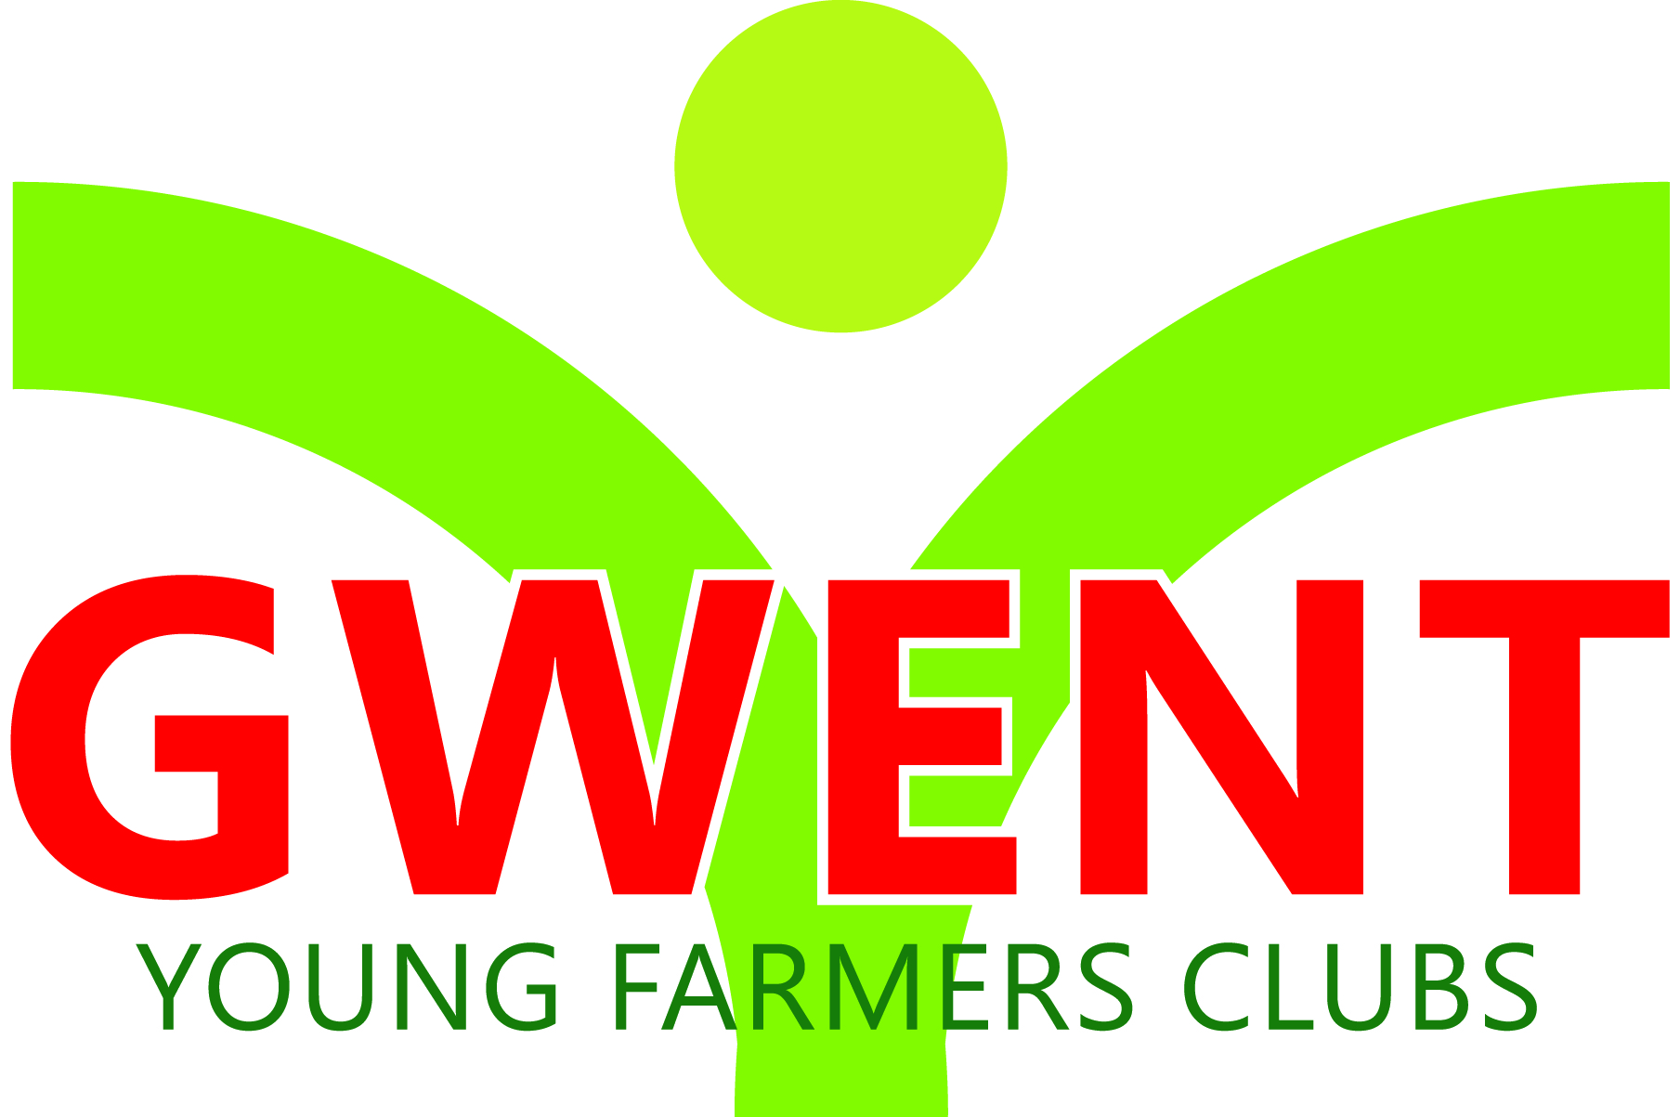
Coleg Gwent,
Usk Campus,
Usk,
Monmouthshire,
NP15 1XJ.
Tel :01291 672602
gwent@yfc-wales.org.uk
www.gwentyfc.co.uk

Dear Committee member,

The next meeting of the Competitions Committee will take place on Monday 6th November 2023 in the YFC Meeting Room at Usk Campus at 8.00pm

Yours faithfully

Laura Morgan
Competition Chairman
AGENDA

- Apologies

- Minutes: to receive minutes of the last meeting held on October 2nd, 2023 (93/CO/2023 – 101/CO/2023)

- Matters Arising

- Correspondence

- Review Autumn Fair

- Carcase Competition

- Public Speaking

- Lamb Carcase competition

- Pig & Dairy 10th December (Stockman of the year)

- AOB

