GWENT FEDERATION OF YOUNG FARMERS’ CLUBS
President: Mr Chris Lewis Chairman: Mr Laura Baker County Organiser: Jemma Rodgers
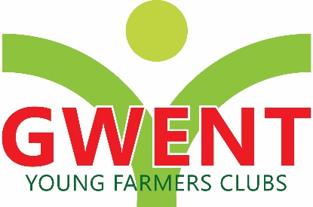
YFC Office, Coleg Gwent,
Usk Campus, Usk,

Monmouthshire,
NP15 1XJ
Tel :01291 672602
gwent@yfc-wales.org.uk
www.gwentyfc.co.uk
27 January 2020

Dear Member
FINANCE AND DEVELOPMENT COMMITTEE

Please note that the next meeting of the Finance and Development Committee will take place on Monday 27TH January 2020 in the YFC Committee Room at Usk at 8pm.

Please make sure that all your Club Representatives are aware of the meeting, and that you have discussed the points on the Agenda, and that your Club views are put forward. Further copies of the agenda will be available on the night.

Yours faithfully

Laura Baker
County chairman
AGENDA

- Apologies

- Minutes: to receive minutes of the meeting held on 18th November 2020

- Correspondence

- Report from County Treasurer

- Update on Banks, Monmouthshire building society & CIO

- Sponsorship for Rally

- Finance and Investment - Fundraising ideas, reminder about the training & development fund

- Social Activities – update from Nerys

- Any Other Business

- Date of Next Meeting, Monday 23rd March 2020

