GWENT FEDERATION OF YOUNG FARMERS’ CLUBS
President : Mr Glyn Davies Chairman : Miss Laura Bowyer Organiser: Mrs Jemma Rodgers

YFC Office,
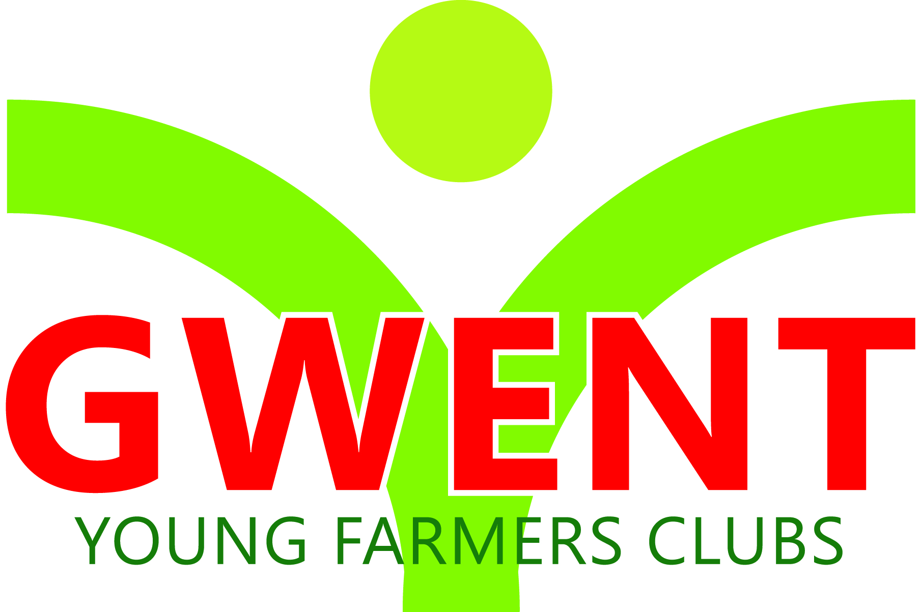
Coleg Gwent,
Usk Campus,
Usk,
Monmouthshire,
NP15 1XJ.
Tel :01291 672602
gwent@yfc-wales.org.uk
www.gwentyfc.co.uk Monday, 16 January 2023

Dear Committee member,

The next meeting of the F&D Committee will take place on Monday 26th September 2022 in the YFC Meeting Room at Usk Campus at 8.00pm or via zoom if needed (please let us know)

Yours faithfully

Laura Bowyer
Gwent YFC Chairman
AGENDA

- Apologies

- Minutes: to receive minutes of the last meeting held on 21.11.2022 (65/F&D – 72/F&D)

- Matters Arising

- Treasurer Report

- Membership figures

- Grants & Sponsorship

- AOB

