GWENT FEDERATION OF YOUNG FARMERS’ CLUBS
President : Mr Alun Morgan Chairman : Miss Abbie Williams Organiser: Mrs Jemma Rodgers

YFC Office,
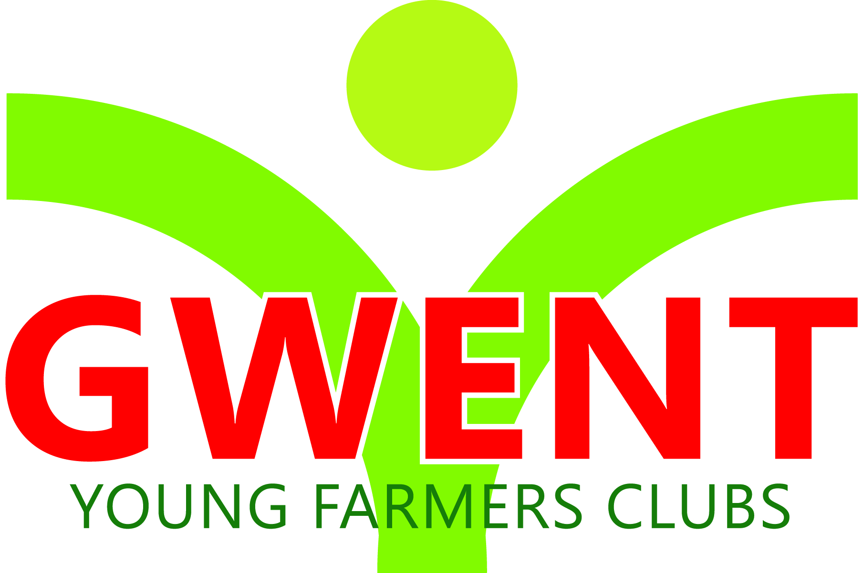
Coleg Gwent,
Usk Campus,
Usk,
Monmouthshire,
NP15 1XJ.
Tel :01291 672602
gwent@yfc-wales.org.uk
www.gwentyfc.co.uk
Monday, 22 March 2021

Dear Member,

The next meeting of the Competitions & Executive Committee will take place on Monday 29th March 2021 at 8.00pm on zoom.

Please make sure that all your Club Representatives are aware of the meeting, and that you have discussed the points on the Agenda, and that your Club views are put forward. Further copies of the agenda will be available on the night.

Yours faithfully

Abbie Williams
County Chairman
AGENDA

- Apologies
- Minutes: to receive minutes of the last meeting held on Monday 1st March 2021 (08/co/21 – 014/co/21)
- Matters Arising
- Correspondence
- Review of past 4 weeks
- Update from Wales/NFYFC meetings
- Competitions
- Summer competitions
- Young handlers/stockjudging May/June
- Calendar for competitions (2021)
- Dolman theatre
- New Job update
- AOB

Next meeting 19th April 2021

