GWENT FEDERATION OF YOUNG FARMERS’ CLUBS
President : Mr Alun Morgan Chairman : Miss Abbie Williams Organiser: Mrs Jemma Rodgers

YFC Office,
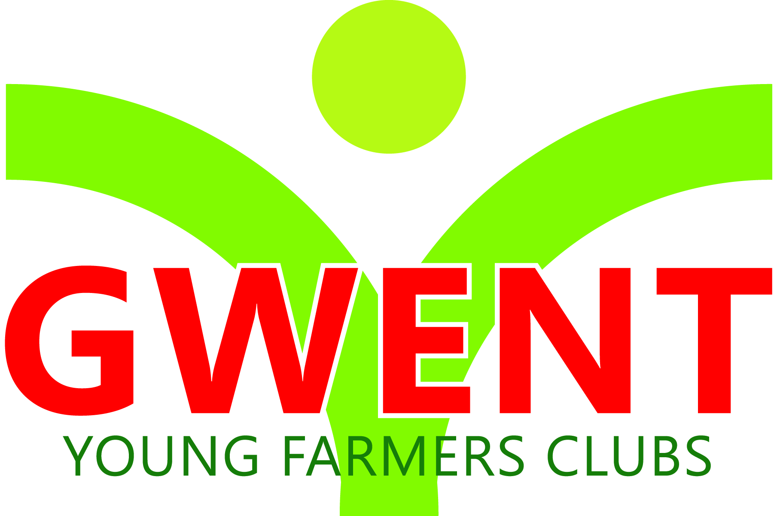
Coleg Gwent,
Usk Campus,
Usk,
Monmouthshire,
NP15 1XJ.
Tel :01291 672602
gwent@yfc-wales.org.uk
www.gwentyfc.co.uk
Monday, 14 December 2020

Dear Member,

The next meeting of the Competitions & Executive Committee will take place on Monday 14Th December at 8.00pm on zoom.

Please make sure that all your Club Representatives are aware of the meeting, and that you have discussed the points on the Agenda, and that your Club views are put forward. Further copies of the agenda will be available on the night.

Yours faithfully

Abbie Williams
County Chairman
AGENDA

- Apologies
- Minutes: to receive minutes of the last meeting held on November 23rd November (23/co/20 – 37/co/20)
- Matters Arising
- Correspondence
- Dates & competitions after Christmas
- Officer training and kiscape anti bullying workshop 18th Jan
- Grants
- LEVY – Due 4th January 2021
- AOB

Next meeting 11th January 2021

